**FWT Calculator Instructions**

**All Greyed-out cells need to a value, even if the value is ZERO. The following is a guide for completing these cells.**

* **Line 1a** – This is the amount of the taxable wages for any given Pay Period/Cycle.
  + Use the Element “FWT GRS TOT” amount within the “Accumulator Results” tab, within the “Accumulators” tab.
* **Line 1b** – This is the number of Pay Periods in a calendar year.
  + i.e. 24 for Active Duty, 12 for Retired Pay, and 26 for Civilian Pay.
* **Line 1d** – Use the W4 amount the member elects in Step 4a.
  + This represents Other Income (Not from Jobs).
* **Line 1f** -Use the W4 amount the member elects in Step 4b.
  + This represents DEDUCTIONS to be withheld other than the standard deduction.
* **Line 1g** – This block is self-explanatory and it will be either $0, $12,600, or $8,400, depending on selections from the W4.
* **Line 2b** – Use the attached “Annual Percentage Method” table from the IRS Publication 15-T to find the appropriate amount.
  + Use the amount from column “A” of the proper row.
* **Line 2c** - Use the attached “Annual Percentage Method” from the IRS Publication 15-T table to find the appropriate amount.
  + Use the amount from column “C” of the row identified in Line 2b.
* **Line 2d** - Use the attached “Annual Percentage Method” table from the IRS Publication 15-T to find the appropriate amount.
  + Use the percentage amount from column “D” of the row identified in Line 2b.
* **Line 3a** - Use the W4 amount from Step 3.
  + The member claims this total amount for dependents.
* **Line 4a** - Use the W4 amount the member elects in Step 4c.
  + Amount of Extra Withholding elected for each pay period.
* **Line 4b** Should equal the amount withheld from the members pay for FWT
  + Validate to Element Type “Deduction,” Element Name “FWT” within “Element Results” tab, within the “Earnings and Deductions” tab.

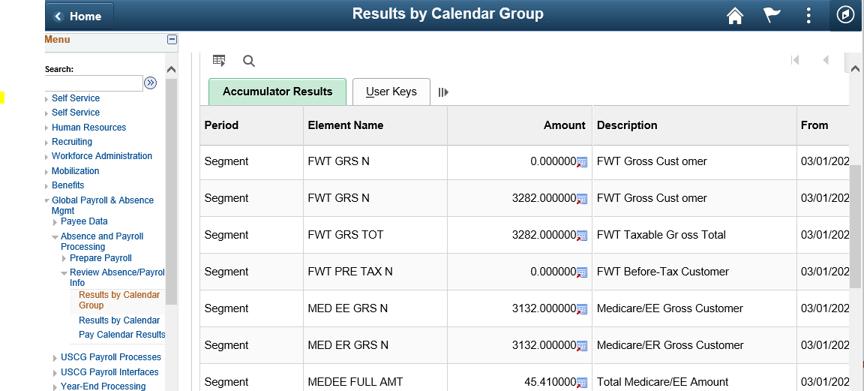

Line 1a - Taxable Wages

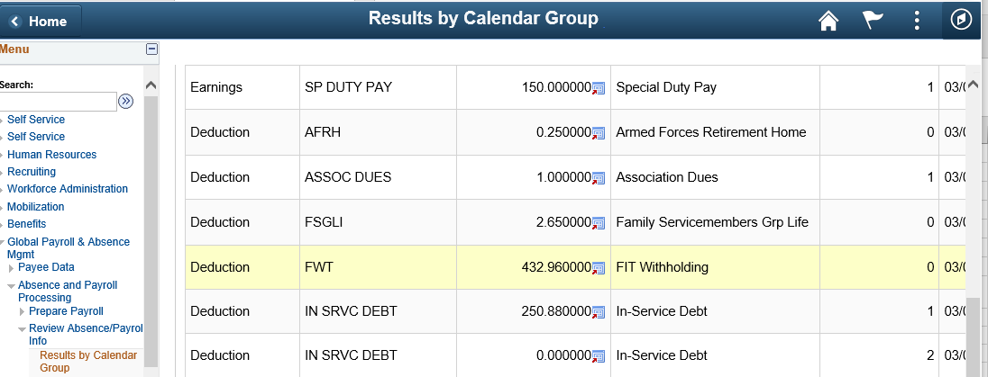

Line 4b - FWT withheld