United States Coast Guard
Ombudsman Program

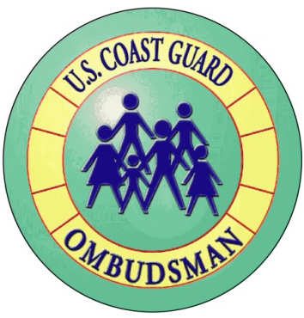
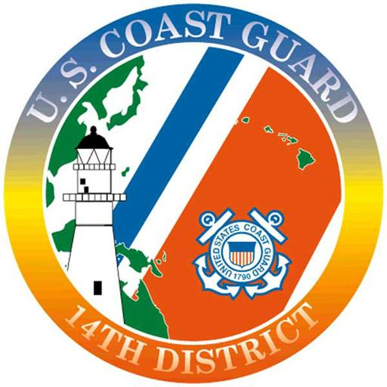
Certificate of Appreciation
Awarded to

Suzie Ombudsman

In recognition of your exceptional service and extraordinary support of our Coast Guard Families

February 17, 2016

Name
Title

