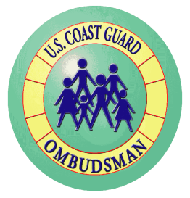

**What does a command ombudsman do?**

* Assist command family members with information and referral.
* Ensure communication between the command and families including newsletter, telephone message, etc.
* Share information about the Ombudsman Program at various command meetings and functions.
* Provide support and assistance during disasters or crisis.

*Estimated 10 - 20 hours a week of your time should fulfill the responsibilities of this position!*

**How do you become a command ombudsman?**

* Applicant should be the spouse of a service member (officer or enlisted, active duty or reservist) who is assigned to the Command.
* The ideal applicant will have experience with the Coast Guard lifestyle, good communication skills, and the desire to help others.
* Contact your command or local ombudsman coordinator for further information on becoming an ombudsman.



POC: Name

Phone: 555-555-5555

E-mail: someone@example.com

Unit Name

Name

Phone: 555-555-5555

E-mail: someone@example.com

Ombudsman Coordinator

**What is a command ombudsman?**

* An official member of the unit’s command staff.
* A resource for the unit’s families.
* A link between families and the command.

Command Ombudsman Wanted