To complete the MOTORCYCLE SAFETY - RIDER TRAINING competency you will first want to assign the needed competency to your unit. You can do this within the ASSIGNMENTS module of TMT.

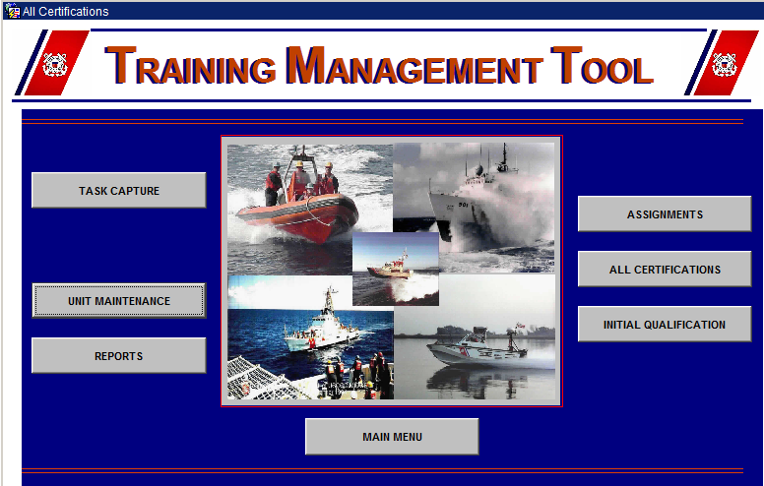

Once in the assignments module you will now want to select the ASSIGN COMPETENCIES TO UNITS.

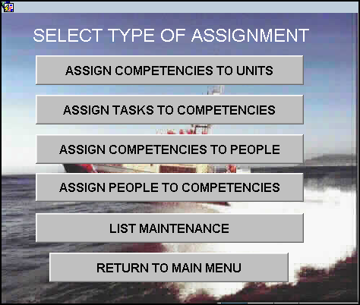

Ensure your unit is selected then click the ASSIGNMENT tab.

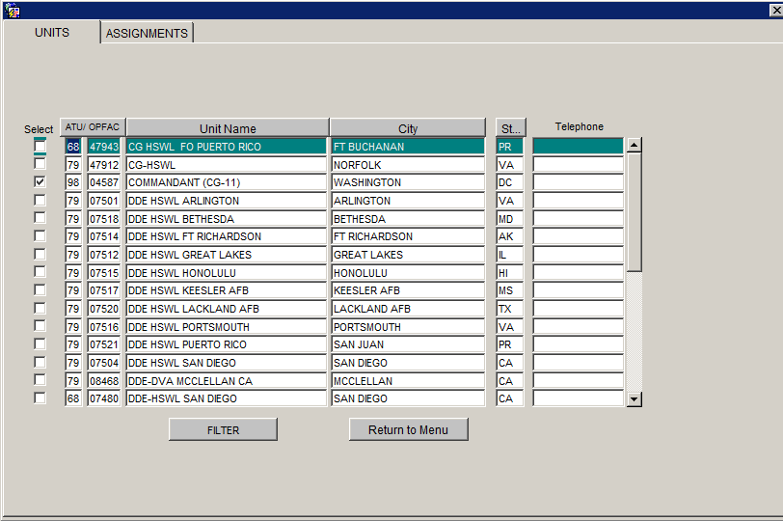
Here is where you will ensure that the needed competency has been assigned to the unit. To do so you will want to  both the right and left hand side the following; %MOTOR%SAFETY%

You will receive results similar to the following;

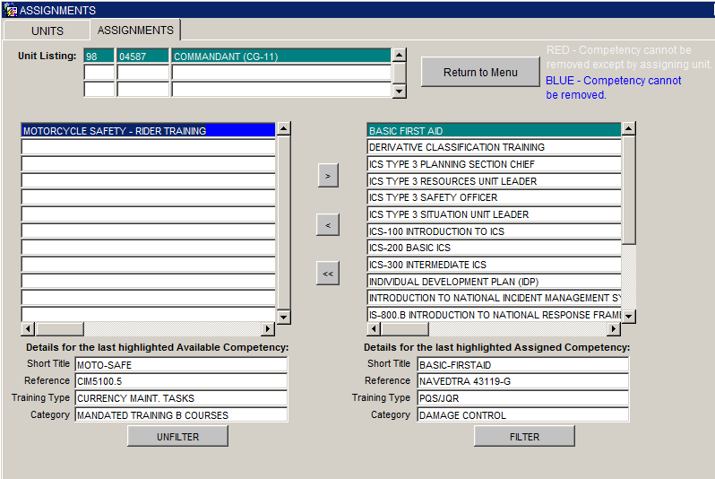

You will then highlight the task and select the to assign to your unit.

Once you have assigned to the unit the needed competency you will then want to assign the competency to the members. To do so you will then select the ASSIGN PEOPLE TO COMPETENCIES within the ASSIGNMENT module.

You again will want to %MOTOR%SAFETY% to select the MOTORCYCLE SAFETY - RIDER TRAINING competency that you selected for you unit.

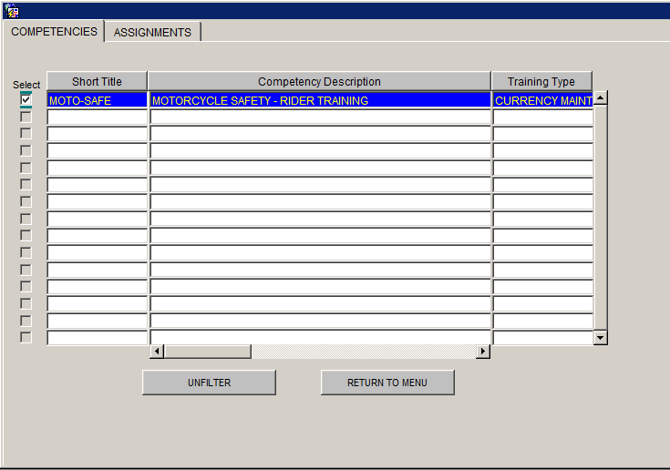

Once selected, you will then select the ASSIGNMENTS tab.
Then highlight the members and select the to assign it to those members.

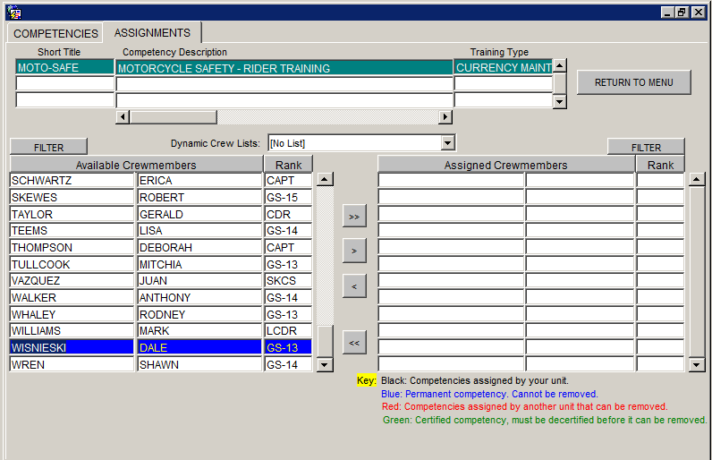

Once this setup portion is complete, you can then start the Task Capture entries.
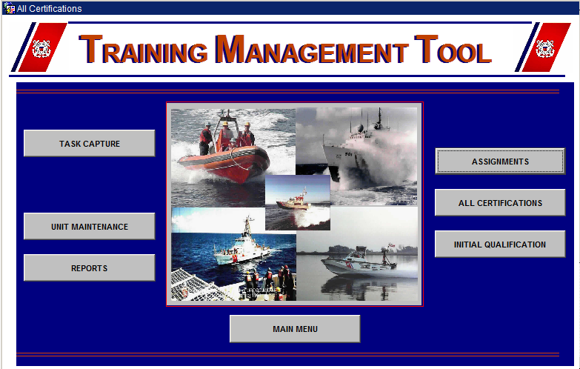

Once in the TASK CAPTURE module you will want to select MOTORCYCLE SAFETY - RIDER TRAINING. You again will want to %MOTOR%SAFETY% to select the MOTORCYCLE SAFETY - RIDER TRAINING

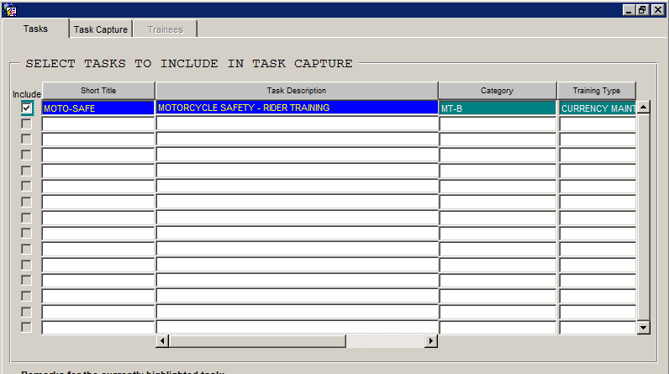

Within the Task Capture tab, you will enter the Instructor, Duration and Completion date;
To select the date using the Calendar feature, click the button; enter any pertinent {remarks} in the Remarks column.
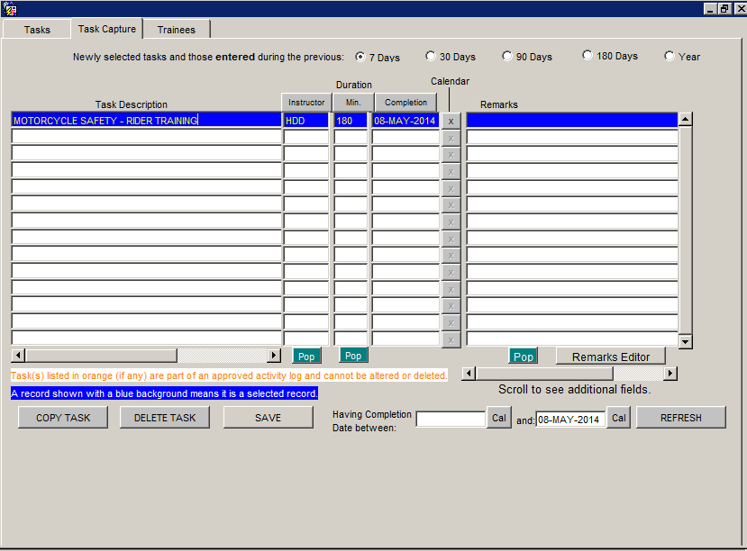

Once that has been completed, you will highlight the training in blue, then select the Trainees tab to select the participants for the training.

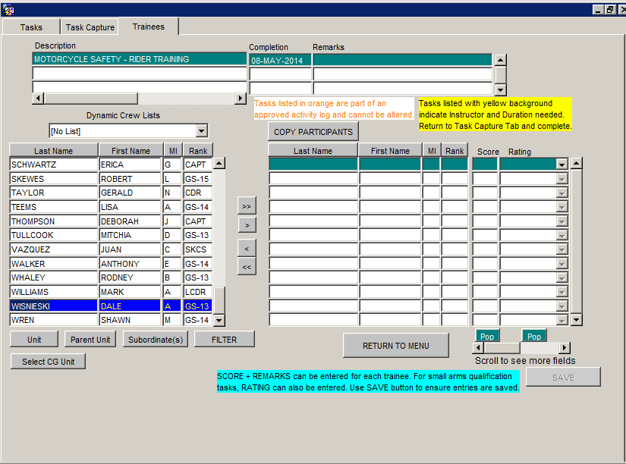

The Trainees tab appears. The task appears at the top of the tab. A list of available crewmembers appears on the left side of the tab. A list of assigned crewmembers appears to the right.
For each crewmember who participated in the selected task, click to select the desired {name} in the available crewmembers section, and then click the button.
Selected names are added to the list of assigned crewmembers, on the right side of the form.
Once the members task capture has been completed you will want to grant competency certification to that eligible crewmember(s) by performing the following steps:
From the TMT main menu, click 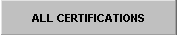.
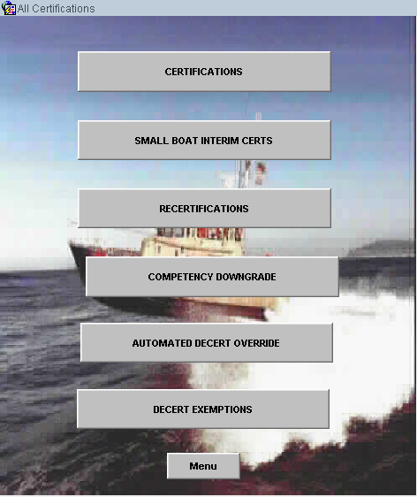

Click 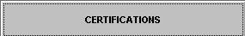.
The Certifications form appears with the Crew tab open (refer to the following figure).
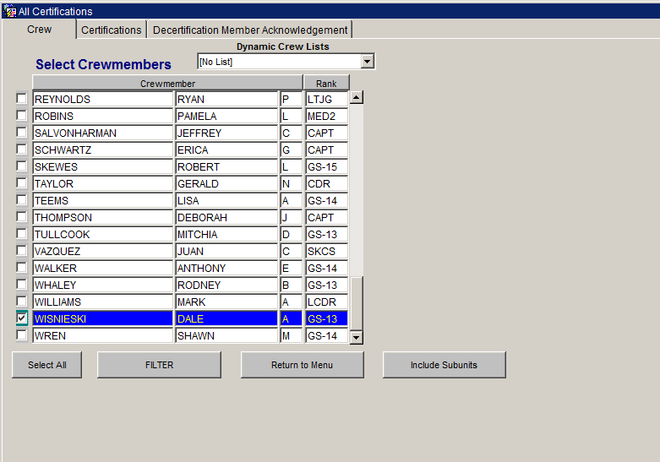
Crew Tab
2. Select the checkbox to the left of each crewmember to select, or click the Select All button to select all listed crewmembers.
A check appears in the box to the left of each selected member.
3. When finished selecting members to be included, click the Certifications tab.
The Certifications tab appears. A list of Selected Crew appears at the top of the tab. A list of All Uncertified Assigned Competencies appears to the left of the tab. A list of Certifications appears to the right of the tab. Certifications earned at a previous unit appear in red.
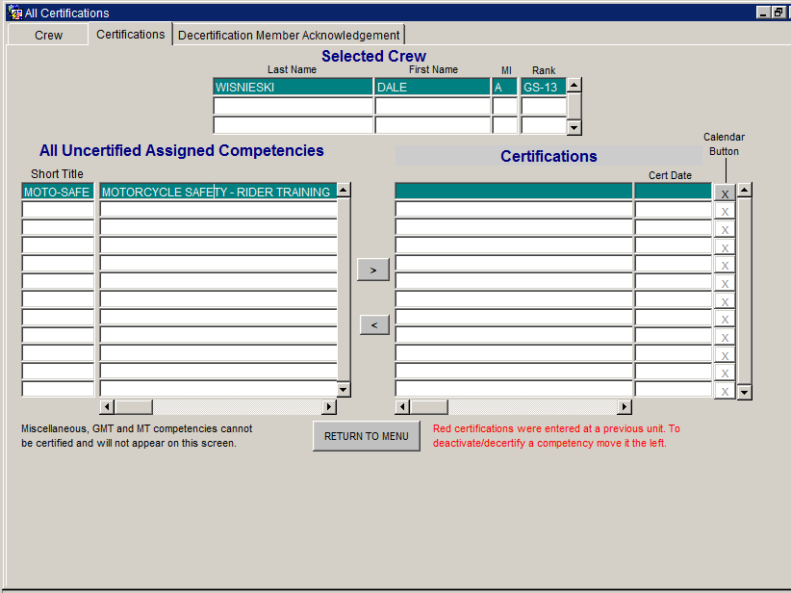
In the All Uncertified Assigned Competencies column, click each {competency} to select for certification, and then click the button.

Unit Training Management Report
This report enables a user to monitor the training requirements of a selected unit. For a selected competency, the report shows the currency status of every member of the unit with respect to every applicable task. Task completion dates are color-coded to graphically denote an individual’s currency status, as shown in the color-coding key on the report.

