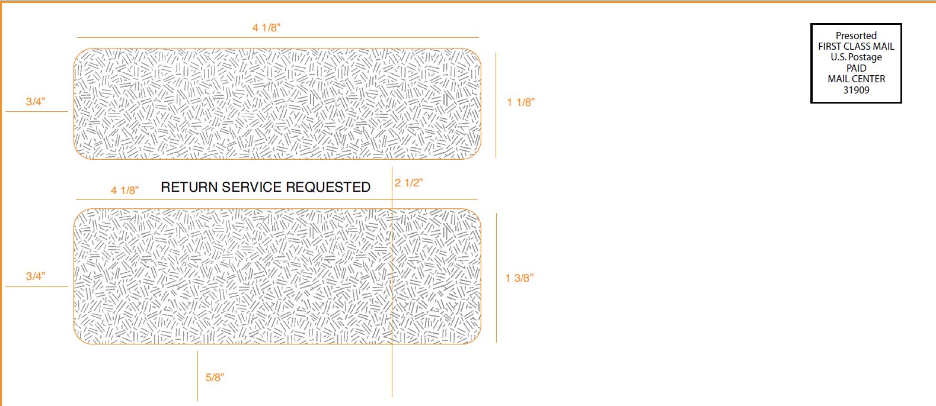

PO Box 6125  
Sioux Falls, SD 57117-6125

Name Line 1  
Name Line 2 Month DD, YYYY  
Address Line 1  
Address Line 2 Account Ending in: 9999  
Address Line 3  
City State Postal Code

Re: Electronic Delivery of Billing Statements Pursuant to your Government Services Travel Card Program Cardholder Account Agreement (“Agreement”)

Dear Government GSA SmartPay® Cardholder,

We appreciate your business as a GSA SmartPay® cardholder. We are writing to inform you of a change in the method by which you will access your billing statements, effective on a date that is within the next two billing cycles (“Effective Date”).

Section 4 of the Agreement between you and Citibank, N.A. (“Bank”) for your Government Travel Card (“Card”), obtained in connection with your employment with your Agency/Organization (as defined in the Agreement), states that Bank may provide your monthly billing statement electronically. Your Agency/Organization has elected to require Bank to deliver billing statements electronically in an effort to reduce our carbon footprint by eliminating the printing of paper statements. As a result, except as provided below, as of the Effective Date you will no longer have the option to receive paper copies of your billing statement, but will need to register in CitiManager (if you are not already registered) in order to receive your billing statements electronically. Here’s how you can do that.

If you are not currently registered in CitiManager, you must register by following the steps below:

1. Navigate to citimanager.com/login
2. Click the Self Registration for Cardholders link
3. Select the 'Fill the Card's Data' radio button and click Continue
4. Enter your card number and name exactly as it appears on your billing statement, no spaces or dashes and click Continue
5. Complete the required fields (*) for self-registration
6. Review the information that displays and when you are finished, click the Confirm button

Once you register in CitiManager, or if you are already registered, you must follow the steps below to access your monthly billing statement:

1. Visit [www.citimanager.com/login](https://urldefense.proofpoint.com/v2/url?u=http-3A__www.citimanager.com_login&d=DwMFAg&c=Od00qP2XTg0tXf_H69-T2w&r=zWaW7d0l2aK8WBttqMADFm2y3X4nEGFq3SA9NDz4VSc&m=4q1LoeDokBnDKO0gS_4E1mCTe02dn4tmAzenOhm8p6k&s=B7rH1l7aPFSZiVDMGzb1NpoGInmpEUBJjHWWbFmQ2pc&e=) and login with your username and password
2. Click on the “Statement” icon in the left navigation bar
3. Click on the statement month tile of the statement to download
4. Scroll down to the “Billed Transactions” section
5. Under the “Billed Transaction” title is a “DOWNLOAD” link
6. Choose the preferred format: CSV, PDF or EXCEL and click the blue “DOWNLOAD” button
7. A gold bar at the bottom of the window gives you the option to either “Open” or ”Save” your statement file

If you do not have access to a computer and cannot register in, or access, CitiManager, please contact your Agency/Organization Program Coordinator (A/OPC), who can change the delivery designation on your behalf to paper statements.  If you cannot reach your A/OPC, you can call the customer service number listed on the back of your card and use our automated phone response system to obtain the balance due and/or make a payment.

It will be your responsibility to download your billing statement every month to ensure that you have access to your charges and the amounts due on your account, or to contact your A/OPC to setup paper statements if you cannot access CitiManager to obtain your billing statement. If you cannot reach your A/OPC, call the customer service number listed on the back of your card.

We appreciate your support of our efforts to go green and help reduce our carbon footprint through the adoption of electronic statements.

Thank you,

Citi Commercial Cards

©2019 Citibank, N.A. All rights reserved. Citi and Citi and Arc Design are trademarks and service marks of Citigroup Inc. or its affiliates and are used and registered throughout the world.