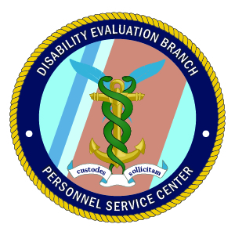

**All necessary CRSC documents and instructions may be found at:** [**http://www.uscg.mil/psd/de/crsc.asp**](http://www.uscg.mil/psd/de/crsc.asp)

If you have further questions please contact the **Coast Guard CRSC Coordinator:**

**ARL-SMB-CGPSC-PSD-CRSC@uscg.mil**

2703 Martin Luther King Jr. Ave SE, Washington, DC 20593-7200

ATTN: CRSC

PSD-MED Website:

[**http://www.uscg.mil/psd/de/crsc.asp**](http://www.uscg.mil/psd/de/crsc.asp)

**Personnel Service Center**

**Medical Administration Branch**

# Combat Related Special Compensation

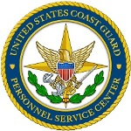

**Personnel Service Center**

#### CRSC Resources

The Service Center for Our Most Important Resource – Our People

**All claims may be sent to:**

**COMMANDER (PSC-PSD)**

**Personnel Service Center 2703 Martin Luther King Jr. Avenue SE,**

**Washington, DC 20593-7200**

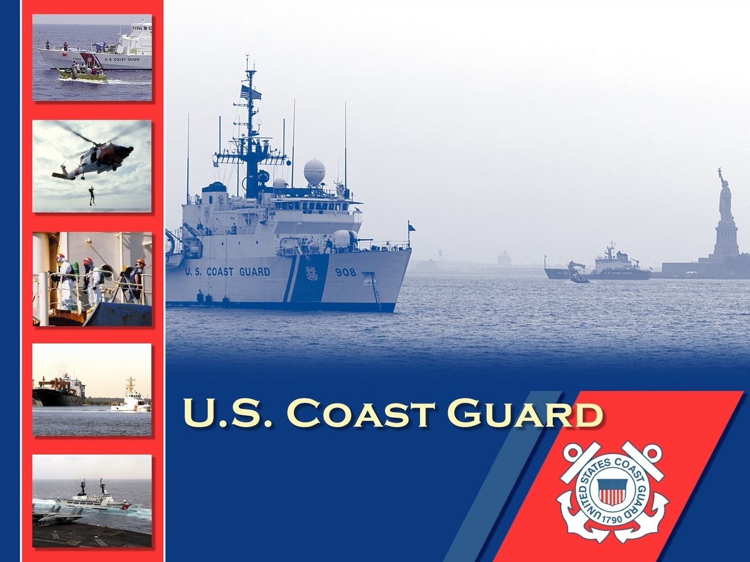

# Eligibility

The Coast Guard Authorization Act of 2015, Section 221, clarifies that members of the Coast Guard are eligible for CRSC. CG members can qualify for CRSC if the disability is incurred during aviation duty, diving duty, rescue swimmer or similar duty, and hazardous service duty onboard a small vessel (such as duty as a surfman). In addition, they may qualify if the disability occurred:

1. In the performance of duties for which special or incentive pay was paid;
2. In the performance of duties related to a statutory mission of the Coast Guard, including:
   * + Law enforcement, including drug or migrant interdiction;
     + Defense readiness;
     + Search and rescue;
     + While engaged in a training exercise for the performance of a duty described in subparagraphs (1) and (2); or
     + As the result of an instrumentality of war.

# Application For CRSC

Coast Guard members receiving disability benefits who believe they are eligible under the clarified criteria or were previously denied CRSC, may submit a claim.

**Use Form DD 2860 for Combat Related Special Compensation found at:** [**http://www.dtic.mil/whs/directives/forms/eforms/dd2860.pdf**](http://www.dtic.mil/whs/directives/forms/eforms/dd2860.pdf).

# Overview

Combat Related Special Compensation (CRSC) provides military Retirees a tax-free monthly compensation that is intended to replace some or all of the retired pay that is withheld due to receipt of Veterans Affairs (VA) compensation. CRSC is payable for disabilities that are found to be related to combat, including disabilities that were incurred in actual combat, while engaged in hazardous service, in the performance of duty simulating war, training for combat or as a result of an instrumentality of war.

#### Combat Related

#### Special Compensation