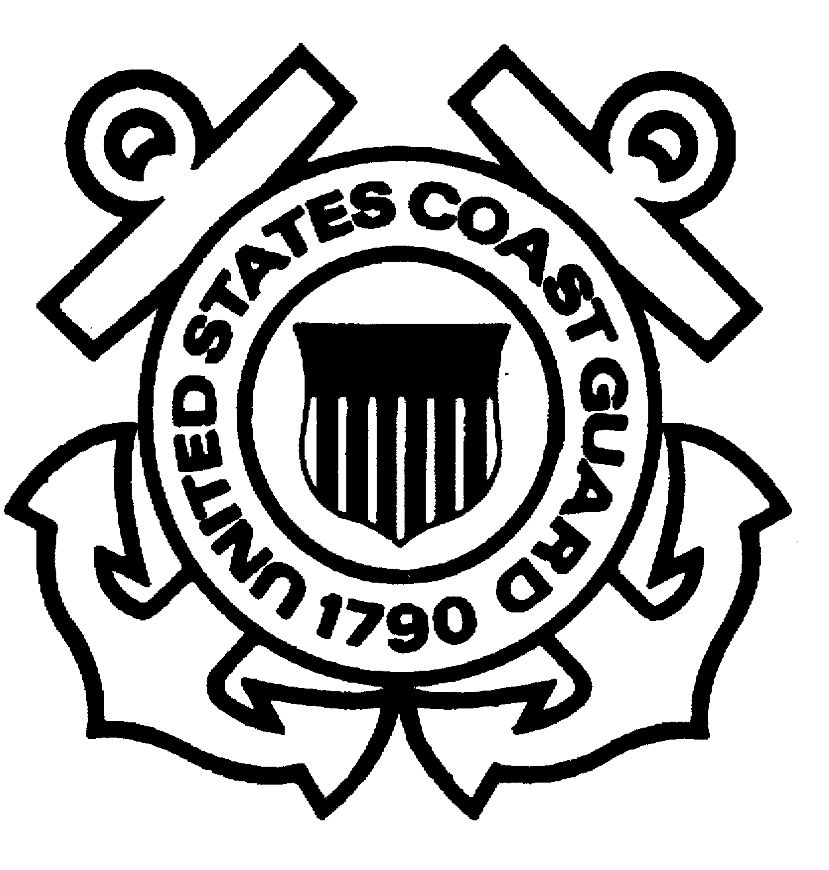

COAST GUARD YARD

“SUPERFUND” UPDATE

DEPARTMENT OF HOMELAND SECURITY 18 February 2009

VOLUME 8 NO 1 U. S. COAST GUARD YARD cm-100
This bulletin is part of our ongoing effort to provide you with the latest Superfund-related information at the Coast Guard YARD. Our goal is to facilitate open communication with members of the community and our employees regarding the YARD’s listing on the Environmental Protection Agency’s (EPA) National Priorities List (NPL) as a Superfund site in 2002. The areas of interest in the YARD’s Superfund initiative are ones of historical contamination, not a result of current-day business practices at the 109 year-old shipyard.

Site #1 (Drydock Sediments)-Yard Clears First Superfund Site:
On September 28, 2007, the Environmental Protection Agency, Region III and the YARD signed a Record of Decision. With concurrence from the Maryland Department of the Environment (MDE), the document officially records the environmental closure of Site 1 at the YARD. Site 1 consisted of sediments under the shipways and old dry dock locations. Through completion of a Remedial Investigation and human health and ecological risk assessment, it was determined that no action was required. Site 1 was initially established as the site with the greatest potential environmental and financial liability to the Coast Guard, so its closure was a major milestone. Although no action was required, the YARD has completed several operational dredge projects over the past years that removed contaminated sediment and transported it to a regulated disposal facility. The “no-action” decision ultimately gained EPA, MDE and the public’s support through a series of informational meetings conducted by the Community Advisory Group (CAG). The CAG raises visibility and awareness of the environmental clean-up efforts at the YARD.

Site #4 & #7 Remedial Investigation and Removal Action: Because of their proximity and similar operational histories, Site #4 (Salvage Lot) and Site #7 (Former Burn Pit) were investigated together resulting in a final Remedial Investigation (RI) report dated August 2006. This report identified the potentially contaminated areas at Sites #4 and #7 and the nature and extent of contamination in these areas.

During February 2007, an Engineering Evaluation/Cost Analysis (EE/CA) for Site #4, the former Salvage Lot, was prepared. The EE/CA describes the proposed remedial action alternatives for the site, including costs, and compares the pros and cons of each. With concurrent review of the EE/CA by the EPA and the MDE, the Coast Guard prepared a draft Removal Action Work Plan in May 2007 that was approved by the EPA and MDE and includes specifications, statement of work, and contracting procedures. The removal action at the former Salvage Lot began on November 12, 2007 and concluded on March 31, 2008. Soils contaminated with lead and polychlorinated biphenyls (PCBs) from historical operations were removed and transported to regulated disposal facilities. Additional sampling was conducted after the soil removal operations to ensure contaminated soils were removed. The removal was conducted to stringent residential standards, the most conservative regulatory standard. Removal of contaminated soils to this level permits unrestricted future use of the property. The sampling confirmed the removal of contaminated soils. The YARD has now begun the process of officially closing Site 4 with a goal of a Record of Decision being in place by the second quarter of FY 2009. A Proposed Remedial Action Plan and Record of Decision have been drafted and sent to MDE and EPA for their review and approval.

On April 1, 2008, the former Salvage Lot was turned over to the new end users - the YARD, Engineering Logistics Center, and Sector Baltimore - for their use as outdoor storage of equipment and supplies.

At Site #7, additional sampling took place during December 2007 and January 2008 in order to collect information needed to complete the Feasibility Study (FS). After receiving regulatory approval for the Draft FS, the Final FS was sent to EPA and MDE during November 2008 and subsequently approved for implementation. A Proposed Remedial Action Plan (PRAP) has been prepared concurrently with the FS. The proposed remedy is to conduct a removal action similar to Site 4. In addition to the removal action, the limited groundwater contamination will be significantly addressed with the removal of the source of the contamination, the soils. In addition, an oxygen-release compound will be distributed to enhance the bioremediation of the contamination. The PRAP will be released during late February 2009 pending comments from the EPA and MDE. The public meeting to discuss the PRAP is scheduled for March 3, 2009 at 7:00 pm . The next Community Advisory Group meeting will be held the same evening following the PRAP meeting. Our goal is to initiate the Removal Action during April/May 2009. The duration of the project is anticipated to be five to six months.

Sites #8 & #9 Work Plans: Work Plans for Site #8, the former Incinerator area, and Site #9, the former Bilge Spoil area, were approved by the EPA and MDE in May 2008. During June and July, monitoring well installation was completed and soil and groundwater samples were collected at these sites. The Draft Remedial Investigation Report for Site 9 was sent to the EPA and MDE for their review and comments the week of February 9, 2009.

Sites #5, #6, #11 and #13 Work Plans and Status: Work Plans (WPs) for Site #5, the former Creosote Stained Soil area; Site #6, the Cosmoline area; Site #11, the Grit Blast area, and Site #13, the area of the former Acid Tanks, are completed and approved by the EPA and MDE. The WPs detail all aspects of sampling and analysis of the sediment and groundwater at the sites. Additional fieldwork remains that includes the installation and sampling of groundwater wells. This work will be conducted during the second/third quarter of 2009. Sites #5, #6, #11 & #13 were originally listed as part of the Superfund site due to elevated levels of arsenic detected in early sampling. In later sampling for the Background Sampling Report discussed below, it was determined that the region has elevated levels of arsenic not just the Sites at the YARD that were sampled. For this reason, EPA and MDE have concurred to have Sites #5, #6, #11 & #13 listed as “Areas of Concern” (AOC) rather than “Operable Units.” This terminology is administrative function only and does not have any effect on the investigative or cleanup aspects of the Superfund Process.

Background Sampling Report: After resolution of final comments, the Background Sampling Report was prepared and distributed in April 2006. The Background Sampling Report identified the background levels of soil, sediment, and surface water contamination in the area. The YARD determined anthropogenic background concentrations that reflected impacts from the industrialized areas around the YARD. The samples at the various potentially contaminated sites at the YARD were compared to the background samples. The accuracy and appropriate application of the background sampling were scrutinized and reviewed by members of the technical partnering team, including the EPA and MDE. The Background Sampling Report will remain an important tool for the investigation and clean-up of the various sites at the YARD to distinguish contamination likely originating from YARD activities from other industrial/commercial sources.
Technical Partnering Meetings and Conference Calls: The most recent technical partnering meetings were held on September 16, 2008 in Pittsburgh at the Tetra Tech offices and on January 26, 2009 at US EPA Region III Headquarters in Philadelphia. Other partnering meetings were held on May 15 and July 22, 2008 to discuss site-related progress and documents. The most recent conference call was held on January 12, 2009 to discuss relevant documents and site- related activities. The next technical partnering meeting is scheduled for March 3, 2009 at the Coast Guard YARD.

Federal Facilities Agreement (FFA): The Coast Guard has completed a Federal Facilities Agreement (FFA) in cooperation with EPA Region III. The FFA is an agreement between the federal property owner (in our case, the U.S. Coast Guard) and the EPA. The FFA defines roles and responsibilities, priorities, and potential penalties during a federal NPL site clean-up process. The FFA was finalized with the last signature on September 11, 2008.

Underground Storage Tank (UST) Remediation: In October 2008, a contract was awarded to ENSR for the underground storage tank removal and site remediation. On January 8, 2009, the vacuum recovery system was turned off in preparation of the tank removal project. This system has been recovering product (a mixture of #2 and #6 oils used as fuel for the boilers) since 2005. The project for the removal of the 50,000 gallon underground tank and over 10,000 tons of oil contaminated soil began on January 27, 2009. The project completion is set for May 25, 2009. The Coast Guard completed a construction project in March 2008 installing three 8,000 gallon above-ground storage tanks that now allows for the removal of the 50,000 gallon underground storage tank.

Landfill Gas to Energy Project: The Coast Guard YARD continues work on this renewable energy project with about 80% of the construction work completed. The Co-Generation Plant will utilize methane gas piped from a nearby City-owned landfill to produce electricity and steam for the shipyard for the next 15 years. The initiative is the largest renewable energy project in Coast Guard history and the first landfill gas co-generation plant in the State of Maryland. The project meets the renewable energy requirements for the entire Department of Homeland Security through 2012. The resulting decrease in greenhouse gases from the project is equivalent to removing 33,000 cars from local highways every year the plant is in operation. A ribbon cutting ceremony is scheduled for April 22, 2009 (Earth Day) to officially start operation of this facility.

ISO 14001: The Yard conducted its ISO 14001 Environmental Management System audit on June 23 and June 24, 2008. Some minor non-conformities were found. No major nonconformities were cited. The audit was conducted by ABS Quality Evaluations (ABS QE). ABS QE is accredited by ANSI-ASQ National Accreditation Board (ANAB). ANAB is the primary accreditation body for Environmental Management Systems in the United States. The Yard’s ISO 14001 program receives an external surveillance audit annually, with a recertification audit every three years. The recertification audit is scheduled for June, 2009. The environmental staff at the YARD conducts monthly internal environmental audits of various programs, shops, departments, and buildings.

Community Advisory Group Meeting: The next Community Advisory Group (CAG) meeting will be held on Tuesday, March 3, 2009 at approximately 8 p.m. The CAG meeting will follow the Site 7 Proposed Remedial Action Plan meeting which will be held the same date at 7:00 pm prior to the CAG meeting. The CAG meetings are for all interested citizens, local business leaders or YARD employees to attend. The meeting will be held at the Coast Guard YARD, in Berry Hall, Building 28A, Baltimore, Maryland 21226.
Communications: Questions or concerns regarding the Yard’s Superfund-related activities are always welcome and can be directed to Ms. Dottie Mitchell, the Yard’s Communications Manager, at 410-636-7238 or dottie.e.mitchell@uscg.mil . The Yard’s mailing address is: Communications Office, Coast Guard Yard, 2401 Hawkins Point Road, Baltimore, Maryland 21226. All documents related to the Yard’s Superfund designation are available at the Yard’s repositories in the North County Library located at 1010 Eastway, Glen Burnie, Maryland and the Brooklyn Park Library located at 1 East 11th Avenue, Baltimore, Maryland. Additional information about the Yard’s Superfund activities can be found on the Yard’s website: www.uscg.mil/hq/cg4/yard

##

