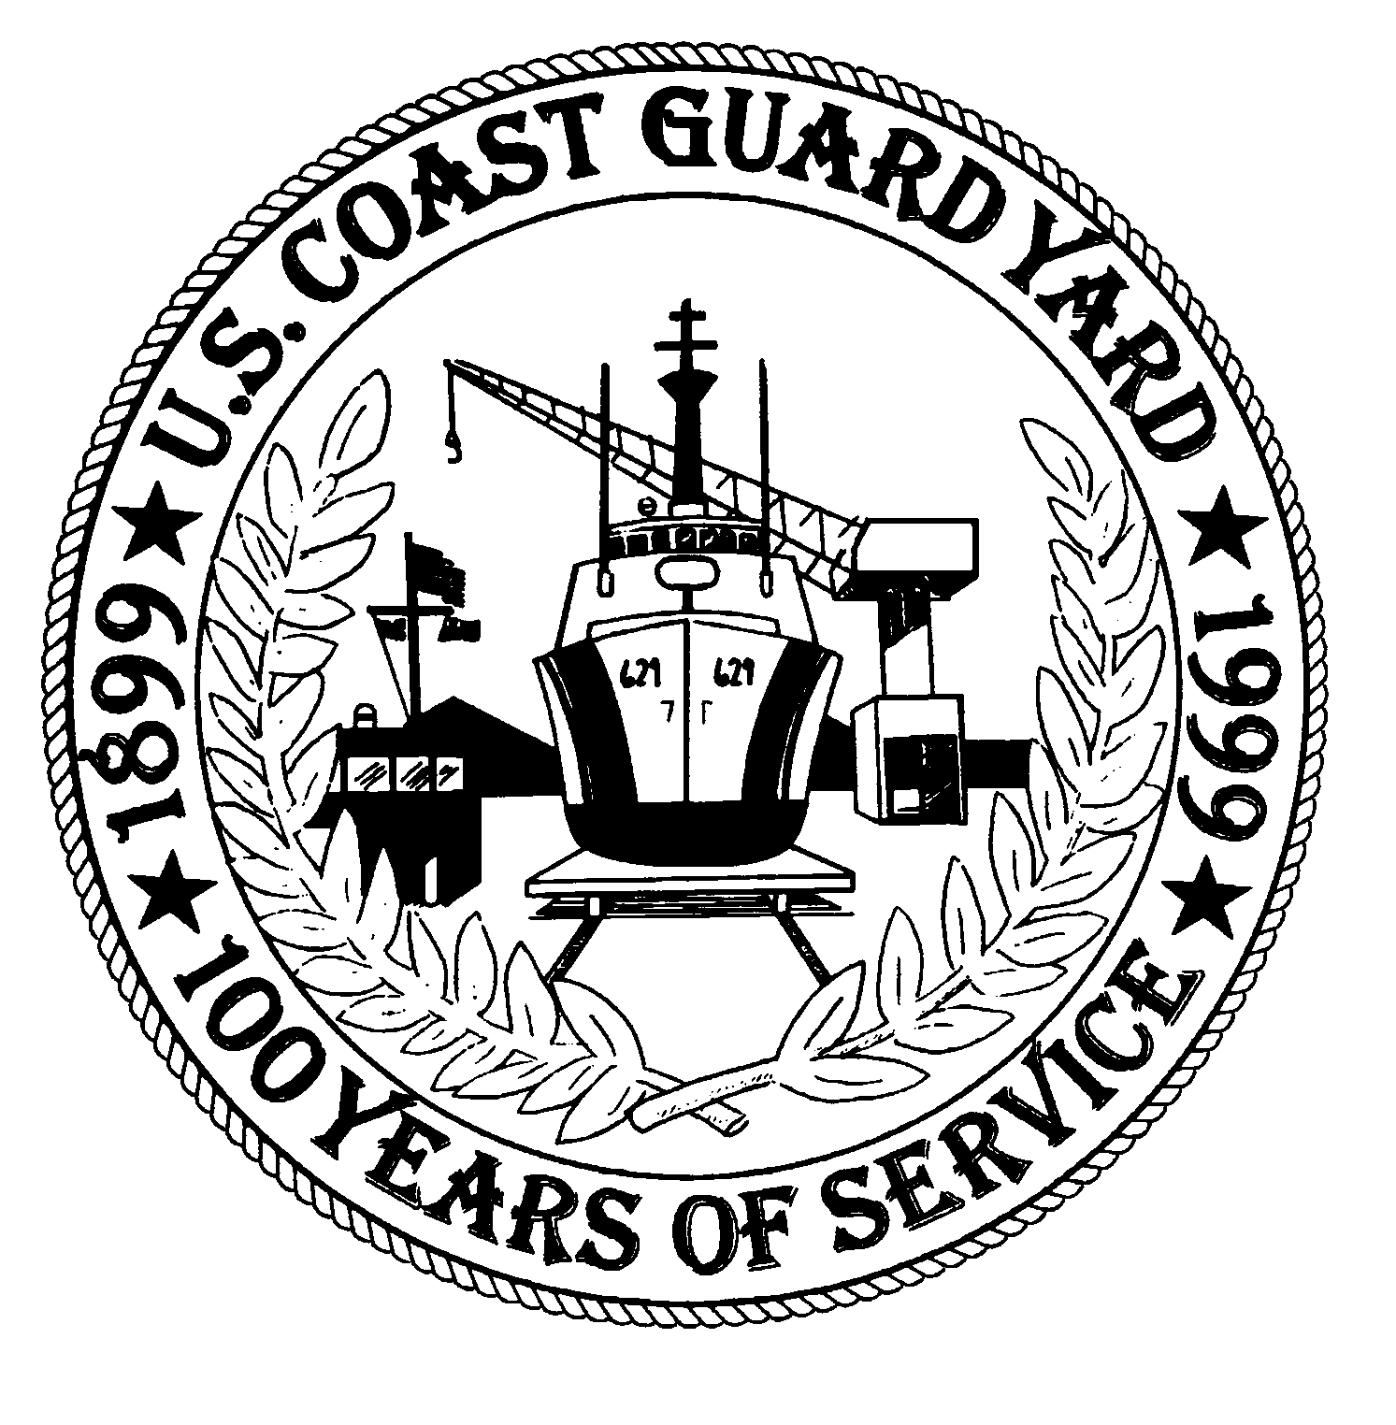
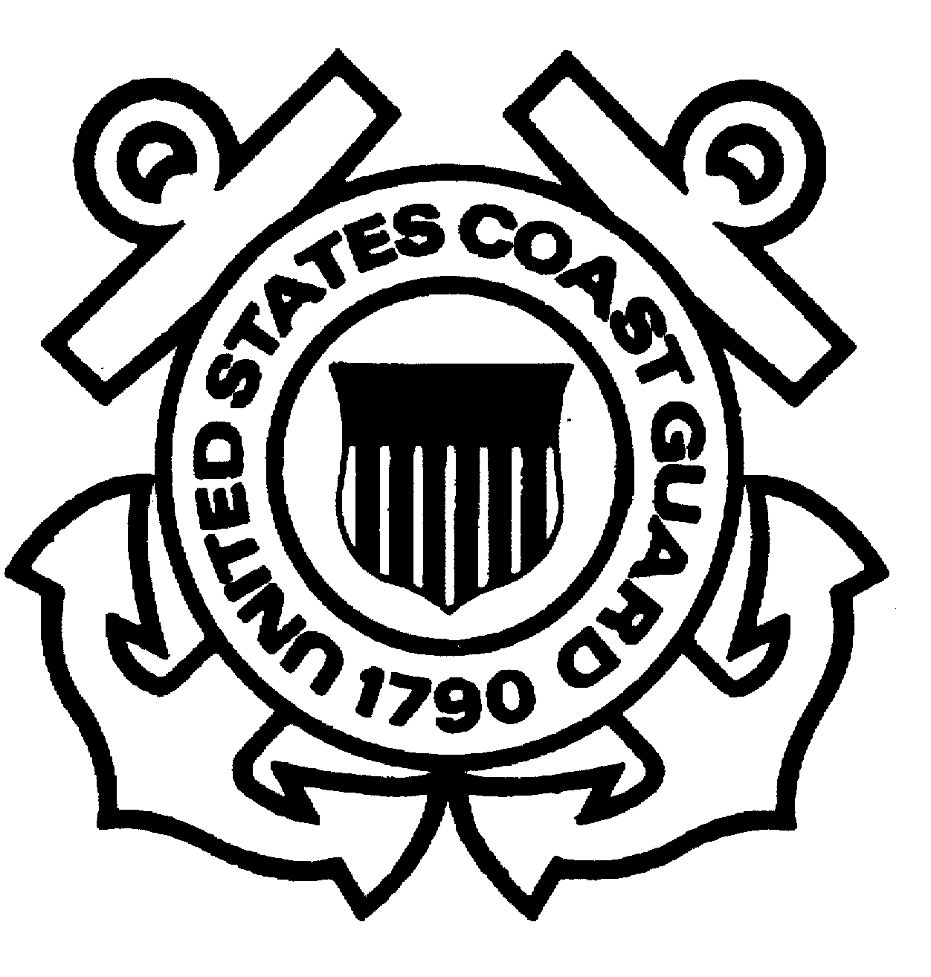

COAST GUARD YARD

“SUPERFUND” UPDATE

DEPARTMENT OF HOMELAND SECURITY 1 July 2008

VOLUME 7 NO 2 U. S. COAST GUARD YARD cm-100
This bulletin is part of our ongoing effort to provide you with the latest Superfund-related information at the Coast Guard YARD. Our goal is to facilitate open communication with members of the community and our employees regarding the YARD’s listing on the Environmental Protection Agency’s (EPA) National Priorities List (NPL) as a Superfund site in 2002. The areas of interest in the YARD’s Superfund initiative are ones of historical contamination, not a result of current-day business practices at the 109 year-old shipyard.

Site #1 (Drydock Sediments)-Yard Clears First Superfund Site:
On September 28, 2007, the Environmental Protection Agency, Region III and the YARD signed a Record of Decision. With concurrence from the Maryland Department of the Environment (MDE), the document officially de-listed Site 1 at the YARD from the National Priority List. Site 1 consisted of sediments under the shipways and old dry dock locations. Through completion of a Remedial Investigation and human health and ecological risk assessment, it was determined that no action was required. Site 1 was initially established as the site with the greatest potential environmental and financial liability to the Coast Guard, so its removal from the list is a major milestone. Although no action was required, the YARD has completed several operational dredge projects over the past years that removed contaminated sediment and transported it to a regulated disposal facility. The “no-action” decision ultimately gained EPA, MDE and the public’s support through a series of informational meetings conducted by the Community Advisory Group (CAG) which raises visibility and awareness of the environmental clean-up efforts at the YARD.

Site #4 & #7 Remedial Investigation and Removal Action: Because of their proximity and similar operational histories, Site #4 (Salvage Lot) and Site #7 (Former Burn Pit) were investigated together resulting in a final Remedial Investigation (RI) report dated August 2006. This report identified the potentially contaminated areas at Sites #4 and #7 and the nature and extent of contamination in these areas.

In February 2007, an Engineering Evaluation/Cost Analysis (EE/CA) for Site #4, the former Salvage Lot, was prepared. The EE/CA describes the proposed remedial action alternatives for the site, including costs, and compares the pros and cons of each. With concurrent review of the EE/CA by the EPA and the MDE, the Coast Guard prepared a draft Removal Action Work Plan in May 2007 which was approved by the EPA and MDE and includes specifications, statement of work, and contracting procedures. The removal action at the former Salvage Lot began on November 12, 2007 and concluded on March 31, 2008. Soils contaminated with lead and polychlorinated biphenyls (PCBs) from historical operations were removed and transported to regulated disposal facilities. Additional sampling was conducted after the soil removal operations to ensure contaminated soils were removed. The removal was conducted to residential standards, the most conservative regulatory standard. Removal of contaminated soils to this level permits unrestricted future use of the property. The sampling confirmed the removal of contaminated soils; the YARD has now begun the process of delisting Site 4 with a goal of a Record of Decision being in place by the end of FY 2008. A Proposed Remedial Action Plan and Record of Decision are currently being drafted for CG review.

On April 1, 2008 the former Salvage Lot was turned over to the new end users - the YARD, Engineering Logistics Center, and Sector Baltimore for their use as outdoor storage of equipment and supplies.

At Site #7, additional sampling took place during December 2007 and January 2008 in order to collect information needed to complete the Feasibility Study (FS). The Draft FS will be ready for EPA and MDE review during July 2008. A Proposed Remedial Action Plan (PRAP) will be prepared concurrently with the FS. We anticipate a removal action similar to Site 4 will be required. Our goal is to initiate the removal action before the close of calendar year 2008.

Sites #8 & #9 Work Plans: On October 31, 2007, a task order was issued to the YARD’s consultant conducting NPL activities at the Yard to prepare Work Plans (WP) for Site #8, the former Incinerator area, and Site #9, the former Bilge Spoil area. The final WPs for Sites #8 and #9 were provided to the Coast Guard in April, 2008 after review and approval from MDE and EPA. The WPs detail all aspects of sampling and analysis of the soil and water at the sites. Sediment sampling was conducted during February 2008 ahead of the WP approval in order to coincide with sampling that was required on a non-related project to repair a bulkhead adjacent to Site 9. This was a cost saving measure and the work will be reviewed by MDE and EPA to ensure it meets their criteria. During June and July, soil sampling, well installation and water samples were collected at Sites 8 & 9. Results of these samples should be available during August 2008.

Sites #5, #6, #11 and #13 Work Plans and Status: On December 7, 2007, the Yard issued a task order to its NPL consultant to prepare Work Plans (WPs) for Site #5, the former Creosote Stained Soil area, Site #6, the Cosmoline area, Site #11, the Grit Blast area and Site #13, the area of the former Acid Tanks. The draft WPs for Sites #5, #6, #11 and #13 will be provided to the Coast Guard during July 2008. The WPs detail all aspects of sampling and analysis of the soil and water at the sites. After Coast Guard review and approval of the WPs, they will be submitted to the EPA and MDE for their review and comment. Sites #5, #6, #11 & #13 were originally listed as part of the Superfund site due to elevated levels of arsenic detected in early sampling. In later sampling for the Background Sampling Report discussed below, it was determined that the region has elevated levels of arsenic not just the Sites at the YARD that were sampled. For this reason, EPA and MDE have concurred to have Sites #5, #6, #11 & #13 listed as “Areas of Concern” (AOC) rather than “Operable Units.” This terminology is administrative function only and does not have any effect on the investigative or cleanup aspects of the Superfund Process.

Background Sampling Report: After resolution of final comments, the Background Sampling Report was prepared and distributed in April 2006. The Background Sampling Report identified the background levels of soil, sediment, and surface water in the area. The samples at the various potentially contaminated sites at the YARD were compared to the background samples. The accuracy and appropriate application of the background sampling were scrutinized and reviewed by members of the technical partnering team, including the EPA and MDE. The Background Sampling Report will remain an important tool for the investigation and clean-up of the various sites at the YARD.
Technical Partnering Meetings and Conference Calls: The most recent technical partnering meeting was held on May 15, 2008 at the CG YARD. Other partnering meetings were held on October 17, 2007 and on January 28 and March 4, 2008 to discuss site-related progress and documents. Recent conference calls were held on January 15, February 26, April 23 and June 12 to discuss relevant documents and site- related activities. The next technical partnering meeting is scheduled for July 22, 2008.

Federal Facilities Agreement (FFA): The Coast Guard has prepared a Federal Facilities Agreement (FFA) in cooperation with EPA Region III. The FFA is an agreement between the federal property owner (in our case, the U.S. Coast Guard) and the EPA. The FFA defines roles and responsibilities, priorities, and potential penalties during a federal NPL site clean-up process. The FFA is currently undergoing final review at Coast Guard Headquarters. The goal is to have this document signed by the end of the summer 2008.

Underground Storage Tank (UST) Remediation: The vacuum recovery system, cut-off trench, and liquid-ring pumps were installed in 2005. The system has been operating for over two years and last fall underwent modifications to further enhance reliability and performance. Results continue to indicate that the system has increased the oil recovery rate. During July 2008, a contract is anticipated to be awarded to develop a work plan for the removal of the old underground tank and contaminated soil. The removal of the underground tank is planned to start in the fall of 2008. The Coast Guard completed a construction project in March 2008 installing three 8,000 gallon above-ground storage tanks that now allows for the removal of the 50,000 gallon underground storage tank.

Landfill Gas to Energy Project: The Coast Guard YARD has begun construction of a renewable energy project. The Co-Generation Plant will utilize methane gas piped from a nearby City-owned landfill to produce electricity and steam for the shipyard for the next 15 years. The initiative is the largest renewable energy project in Coast Guard history and the first landfill gas co-generation plant in the State of Maryland. The project meets the renewable energy requirements for the entire Department of Homeland Security through 2012. The "green" initiative reduces the shipyard's vulnerability by eliminating dependence on local off-site power sources, a plus for natural disaster planning and homeland security. The resulting decrease in greenhouse gases from the project is equivalent to removing 33,000 cars from local highways every year the plant is in operation. Construction completion is scheduled for April 2009.

ISO 14001: The Yard conducted its ISO 14001 Environmental Management System audit on June 23 and June 24, 2008. Some minor nonconformities were found. No major nonconformities were cited. The audit was conducted by ABS Quality Evaluations (ABS QE). ABS QE is accredited by ANSI-ASQ National Accreditation Board (ANAB). ANAB is the primary accreditation body for Environmental Management Systems in the United States. The Yard’s ISO 14001 program receives an external surveillance audit annually, with a recertification audit every three years. The environmental staff at the YARD conducts monthly internal environmental audits of various programs, shops, departments, and buildings.

Community Advisory Group Meeting: The next Community Advisory Group (CAG) meeting will be held on Tuesday, July 22, 2008 at 4 p.m. We are holding the meeting in the afternoon to see if that time is more convenient for interested citizens, local business leaders or YARD employees to attend. The meeting will be held at the Coast Guard YARD, in Berry Hall, Building 28A, Baltimore, Maryland 21226.
Communications: Questions or concerns regarding the Yard’s Superfund-related activities are always welcome and can be directed to Ms. Dottie Mitchell, the Yard’s Communications Manager, at 410-636-7238 or dottie.e.mitchell@uscg.mil . The Yard’s mailing address is: Communications Office, Coast Guard Yard, 2401 Hawkins Point Road, Baltimore, Maryland 21226. All documents related to the Yard’s Superfund designation are available at the Yard’s repository in the North County Library located at 1010 Eastway, Glen Burnie, Maryland. Additional information about the Yard’s Superfund activities can be found on the Yard’s website: www.uscg.mil/hq/cg4/yard

##

