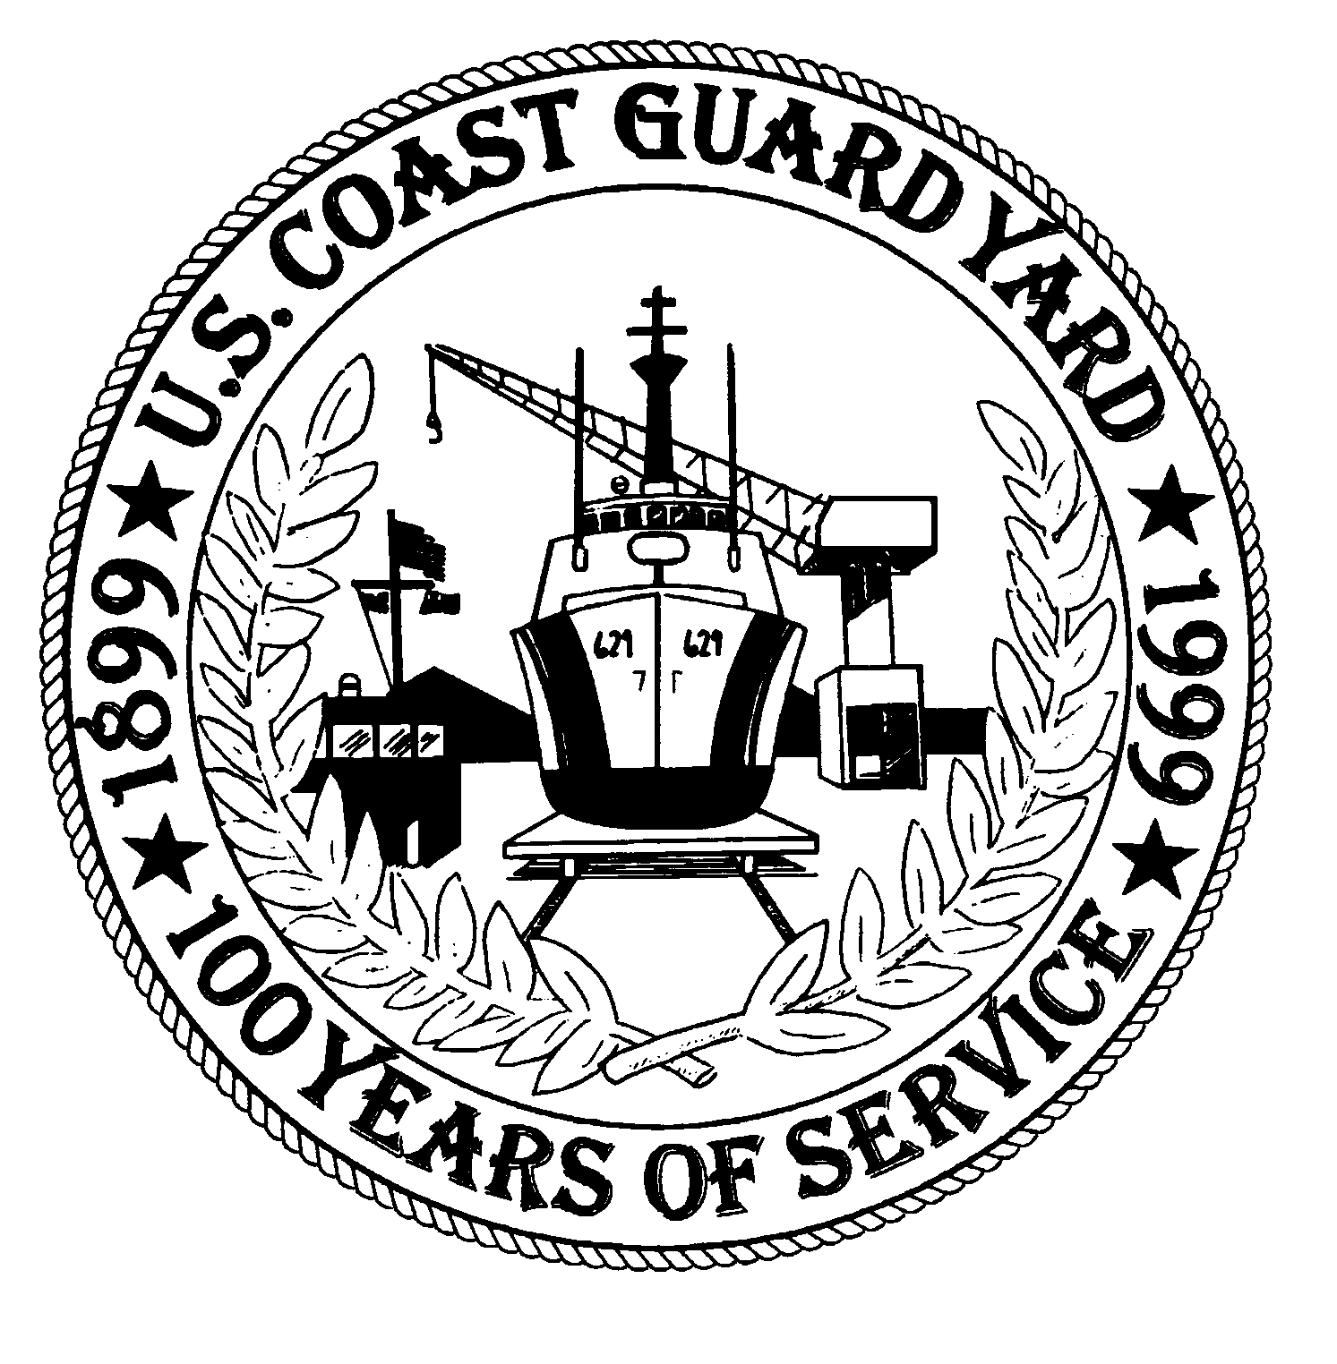
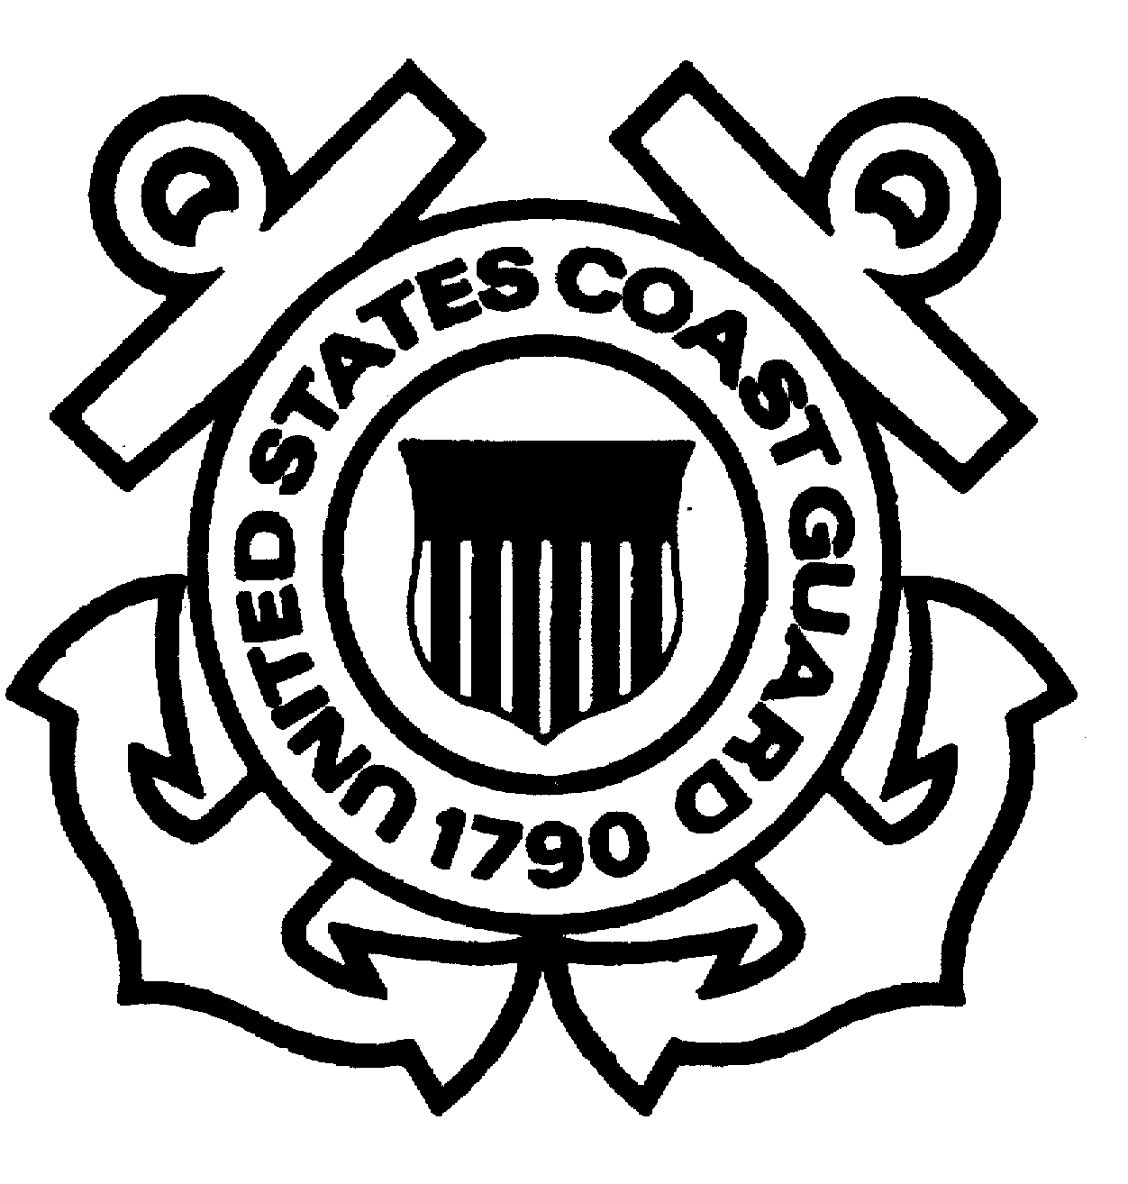

COAST GUARD YARD

“SUPERFUND” UPDATE

DEPARTMENT OF HOMELAND SECURITY 15 January 2008

VOLUME 7 NO 1 U. S. COAST GUARD YARD cm-100
This bulletin is part of our ongoing effort to provide you with the latest Superfund-related information at the Coast Guard Yard. Our goal is to facilitate open communication with members of the community and our employees regarding the Yard’s listing on the Environmental Protection Agency’s (EPA) National Priorities List (NPL) as a Superfund site in 2002. The areas of interest in the Yard’s Superfund initiative are ones of historical contamination, not a result of current-day business practices at the 108 year-old shipyard.

Site #1 (Drydock Sediments)-Yard Clears First Superfund Site:
On September 28, 2007, the Environmental Protection Agency, Region III and the Yard signed a Record of Decision. With concurrence from the Maryland Department of the Environment (MDE), the document officially de-listed Site 1 at the Yard from the National Priority List. Site 1 consisted of sediments under the shipways and old dry dock locations. Through completion of a Remedial Investigation and human health and ecological risk assessment, it was determined that no action was required. Site 1 was initially established as the site with the greatest potential environmental and financial liability to the Coast Guard, so its removal from the list is a major milestone. Although no action was required, the Yard has done several dredge projects over the past years that removed contaminated sediment and transported it to a regulated disposal facility. The no-action ultimately gained EPA, MDE and the public’s support through a series of informational meetings conducted by the Community Action Group which raised visibility and awareness of the environmental clean-up efforts at the Yard. The next location to be addressed is the Salvage Lot (Site #4) that is currently undergoing clean-up.

Site #4 & #7 Remedial Investigation : Because of their proximity and similar operational histories, Site #4 (Salvage Lot) and Site #7 (Former Burn Pit) were investigated together resulting in a final Remedial Investigation (RI) report dated August 2006. This report identified the potentially contaminated areas at Sites #4 and #7 and the nature and extent of contamination in these areas.

In February 2007, an Engineering Evaluation/Cost Analysis (EE/CA) for Site #4, the former Salvage Lot, was prepared. The EE/CA describes the proposed remedial action alternatives for the site, including costs, and compares the pros and cons of each. With concurrent review of the EE/CA by the EPA and the MDE, the Coast Guard prepared a draft Removal Action Work Plan in May 2007 which was approved by the EPA and MDE and includes specifications, statement of work, and contracting procedures. The removal action of the former Salvage Lot began on November 12, 2007. Soils contaminated with lead and polychlorinated biphenyls (PCBs) from historical operations are being removed and transported to regulated disposal facilities. The removal action should be completed by late-January 2008. Additional sampling will be conducted after the soil removal operations to ensure all contaminated soils have been removed. If sampling confirms the removal of all contamination, the Yard will begin the process of delisting Site 4 during 2008.

At Site #7, additional sampling took place during December 2007 and January 2008 in order to collect information needed to complete the Feasibility Study (FS). The Draft FS will be ready for EPA and MDE review in spring 2008. A Proposed Remedial Action Plan (PRAP) will be prepared concurrently with the FS. We anticipate a removal action will be required: Our goal is to initiate the action during the fall of 2008.

Sites #8 & #9 Work Plans: On October 31, 2007, a task order was issued to the Yard’s consultant conducting NPL activities at the Yard to prepare Work Plans (WP) for Site #8, the former Incinerator area, and Site #9, the former Bilge Spoil area. The draft WPs for Sites #8 and #9 will be provided to the Coast Guard in January and February, 2008, respectively. The WPs detail all aspects of sampling and analysis of the soil and water at the sites. After Coast Guard review and approval of the WPs, we will submit them to the EPA and MDE for their review and comment. At the October 17 and December 12, 2007 partnering meetings, the proposed WPs for these sites were discussed in detail with EPA and MDE. The parties agreed in concept on the direction of the plans.

Sites #5, #6, #11 and #13 Work Plans: On December 7, 2007, the Yard issued a task order to its NPL consultant to prepare Work Plans (WPs) for Site #5, the former Creosote Stained Soil area, Site #6, the Cosmoline area, Site #11, the Grit Blast area and Site #13, the area of the former Acid Tanks. The draft WPs for Sites #5, #6, #11 and #13 will be provided to the Coast Guard during spring 2008. The WPs detail all aspects of sampling and analysis of the soil and water at the sites. After Coast Guard review and approval of the WPs, they will be submitted to the EPA and MDE for their review and comment.

Background Sampling Report: After resolution of final comments, the Background Sampling Report was prepared and distributed in April 2006. The Background Sampling Report identified the background levels of soil, sediment, and surface water in the area. The samples at the various potentially contaminated sites at the Yard were compared to the background samples. The accuracy and appropriate application of the background sampling was scrutinized and reviewed by members of the technical partnering team, including the EPA and MDE. The Background Sampling Report will remain an important tool for the investigation and clean-up of the various sites at the Yard.
Technical Partnering Meetings and Conference Calls: The most recent technical partnering meeting was held on December 12, 2007 at EPA Region III in Philadelphia. Other partnering meetings were held on June 28, August 28 and October 17, 2007 to discuss site-related progress and documents. Conference calls were held on July 25, September 19, October 19 and November 15, 2007 to discuss relevant documents and site- related activities. During the most recent meeting on December 12, the primary discussions focused on Sites 5, 6, 11, 13. These four sites were initially considered areas of interest due to elevated levels of arsenic detected in the soils. After completion of the Background Sampling Report discussed above, the data will be revisited as arsenic is naturally elevated in this area and is likely not a result of historical contamination at the site. The next technical partnering meeting is scheduled for January 28, 2008.

Federal Facilities Agreement (FFA): The Coast Guard is preparing a Federal Facilities Agreement (FFA). The FFA is an agreement between the federal property owner (in our case, the U.S. Coast Guard) and the EPA. The FFA defines roles and responsibilities, priorities, and potential penalties during a federal NPL site clean-up process. The Coast Guard and EPA have held the initial meeting to discuss the terms of the document. The FFA is currently undergoing review at Coast Guard Headquarters. A target completion date is January 31, 2008.

Underground Storage Tank (UST) Remediation: The vacuum recovery system, cut-off trench, and liquid-ring pumps were installed in 2005. The system has been operating for nearly two years and recently underwent modifications to further enhance reliability and performance. Results continue to indicate that the system has increased the oil recovery rate. During November 2007, a contract was awarded to develop a work plan for the removal of the old underground tank and contaminated soil. The removal of the underground tank is to start in the summer of 2008. The Coast Guard has awarded a construction project to install three 8,000 gallon above-ground storage tanks that, when complete, will allow for the removal of the 50,000 gallon underground tank. The construction of this project is ongoing; the new tanks should be in service during February 2008.

ISO 14001: The Yard conducted its ISO 14001 Environmental Management System recertification audit on July 23 and July 24, 2007. Some minor nonconformities and remarks were found. No major nonconformities were cited. The audit was conducted by ABS Quality Evaluations (ABS QE). ABS QE is accredited by ANSI-ASQ National Accreditation Board (ANAB). ANAB is the primary accreditation body for Environmental Management Systems in the United States. The Yard’s ISO 14001 program receives an external surveillance audit annually, with a recertification audit every three years. The 2008 external surveillance audit is scheduled for May 12 and 13. The environmental staff at the Yard conducts monthly internal audits of various programs, shops, departments, and buildings.

Landfill Gas Co-Generation Plant Groundbreaking

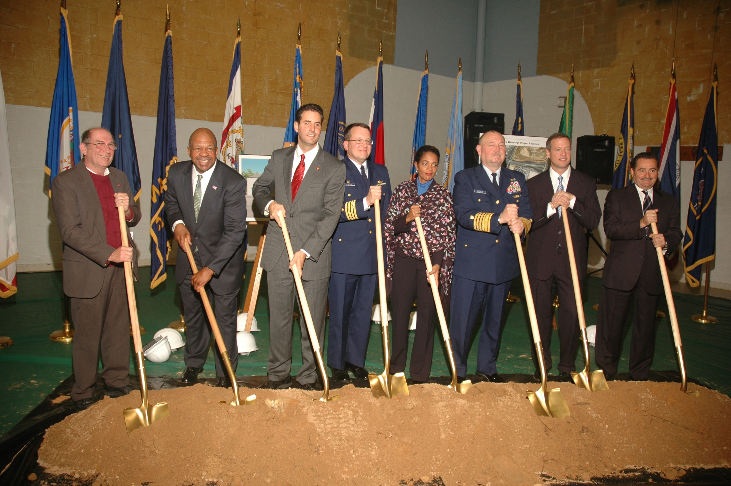
With the rousing applause of over 500 Yard employees and guests, the official party gripped shovels and broke ground to officially commence construction of the Yard's Landfill Gas Co-Generation Plant, expected to be operational on Earth Day, 2009.

The Yard held an All-Hands Groundbreaking Ceremony on November 13, 2007 to begin construction of the Landfill Gas Co-Generation Plant. Honored dignitaries included (left to right): U.S. Congressman Wayne Gilchrest of the 1st District of Maryland; U.S. Congressman Elijah Cummings, Chairman of the Subcommittee on Coast Guard & Maritime Transportation and representative of Maryland's 7th District; U.S. Congressman John Sarbanes of the 3rd District of Maryland; Captain Stephen Duca, Commanding Officer, Coast Guard Yard; Mayor Sheila Dixon of the City of Baltimore; Admiral Thad Allen, Commandant of the Coast Guard; Governor Martin O'Malley of Maryland, and Mr. George Sakellaris, President of AMERESCO Federal Solutions, Inc.

The Co-Generation Plant will utilize methane gas piped from a nearby City-owned landfill to produce electricity and steam for the shipyard for the next 15 years. The initiative is the largest renewable energy project in Coast Guard history and the first landfill gas co-generation plant in the State of Maryland. The project meets the renewable energy requirements for the entire Department of Homeland Security through 2012. The "green" initiative reduces the shipyard's vulnerability by eliminating dependence on local off-site power sources, a plus for natural disaster planning and homeland security. The resulting decrease in greenhouse gases from the project is equivalent to removing 33,000 cars from local highways every year the plant is in operation.
Community Advisory Group Meeting: The next Community Advisory Group (CAG) meeting will be held on Monday, January 28, 2008 at 7 p.m. The meeting will be held at the Curtis Bay Recreation Center, 1630 Filbert Street, Baltimore, Maryland 21226.
Communications: Questions or concerns regarding the Yard’s Superfund-related activities are always welcome and can be directed to Ms. Dottie Mitchell, the Yard’s Communications Manager, at 410-636-7238 or dottie.e.mitchell@uscg.mil . The Yard’s mailing address is: Communications Office, Coast Guard Yard, 2401 Hawkins Point Road, Baltimore, Maryland 21226. All documents related to the Yard’s Superfund designation are available at the Yard’s repository at the North County Library located at 1010 Eastway in Glen Burnie, Maryland. Additional information about the Yard’s Superfund activities can be found on the Yard’s website: www.uscg.mil/hq/cg4yard.

##

