**Travel Manager Tool**

**Overview** – This application takes standard text formatted Paymentnet reports and merges Direct Access (DA) employee data to produce excel file outputs which include information on the employee and their organizational placement. These instructions explain how to setup and use this tool.

**Step 1** – Execute the batch file below. This file will create a new directory/folder called u:\TravelManagerTool, create blank text files to provide template names for the downloads in the latter steps, and download a copy of the Travel Manager Tool to this new directory/folder.



**Step 2** – Log into Paymentnet using your Travel Manager Userid. <https://gov1.paymentnet.com/>.

**Step 3** – The next part of the process is to standardize the account display information within paymentnet. This is critical for the imports to work. If the imports into the TravelManagementTool do not work, it is probably due to your profile setup being wrong. Follow the steps in the attached guide to configure your Paymentnet profile:



**Step 4** – Open the database file DA_PAYMENTNET_TM_TOOL.accdb by double clicking on the file from within the U:\TravelManagerTool folder (Note – the U: Drive is you’re my documents folder)..

**Step 5** – When the database opens, **if** you see the SECURITY WARNING as shown below, then click on options and select ENABLE THIS CONTENT. You will only see this if you do not have your U: drive as a trusted location.

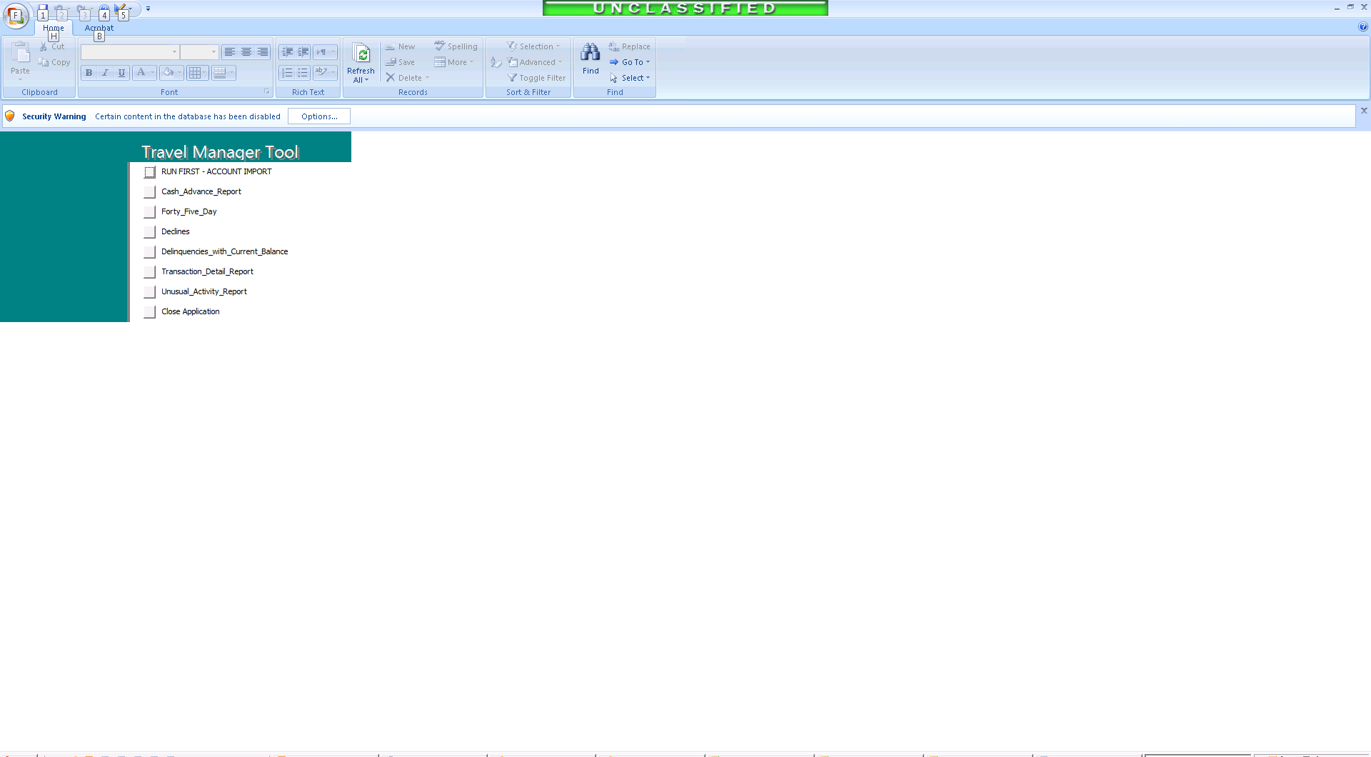

**Step 6** – Click on the RUN FIRST – ACCOUNT IMPORT and then following the instructions displayed to run an account query, create an export download, and save the downloaded file to the u:\TravelManagerTool folder. **When you save the file ensure you select the file name “Accounts-Export.txt” that is located in the folder and overwrite the file.**

The attached file provides screen shot of the various Paymentnet download steps.



**Step 7** – For each report, select the appropriate report button, follow the instructions for preparing the report, and ensure you save the downloaded report to the matching file name located in the u:\TravelManagerTool folder (CRITICAL – if you don’t name the file exactly as shown the tool will not work!!!):